Blockchain and Economics-舒了洋

**Q : How do decentralized blockchain applications affect the cost of verification and the cost of networking?How do blockchain application affect market power?**

· Verification - Tracking , Settling & Enforcing Transactions and Contracts

- Ability to Lower Costs to Verify Transactions ,Particularly Digital Assets

·Direct Costs

there may be a cost trade-off (权衡取舍) that blockchain could have a lower cost of

verification.That doesn’t always, but a lot of verification in finance has multiple back offices trying to reconcile(使……一致) between ledgers. And blockchain lower the direct costs of the back office

·Privacy and Data Leakage Costs(泄露成本)

·Censorship Risks

·Settlement - Timeliness and Certainty of Finality

·Costs of Trust

Code & Consensus Protocol vs. Trust in Central Intermediary

·Economic Rents due to Market Power

·Networking - Moving Property Rights across a Network

- Ability to Lower Costs to Develop and Operate a Network

·Tokens provide Opportunity to Pre Fund Development

token economics might not have much to do with many things, but it might incentive (激励) and help fund the network.It’s a new form of crowdfunding.

·Tokens provide Incentive Mechanism During Operating Phase

**What’s the biggest commercial thing that’s going on right now in big data?**

The dominant revenue model in tech today , whether it ‘s a big tech like Facebook and Google and so far or any tech-- the dominant revenue model , not the only , is basically give me some of your data,let me analyze it . And either advertise against it or somehow in theses days use machine learning and AI to analyze it. And really market other products back to you maybe.

and with blockchain ,maybe you can get a little bit more privacy if you wish it.It might be part of the revenue model.

**Censorship(审查制度)**

When you’re dealing with a central authority, a commercial bank, they can decide whether to extend credit or not. That ‘s a form of censorship.It’s a form of allocating something.

Distributed decentralized platforms are more censorship resistant.

**Blockchain vs. Internet**

· both open protocols (broadly)

· Both Transport packets of data on distributed networks

·Property Rights vs. Content

·Both can have Apps built upon Protocol or Cryptocurrency level

·Both said to be Open Network Development

·Though Centralized through groups such as ICANN or Bitcoin Core Developers

·Interoperability (互操作性)

· A blockchain is akin to a Private Intranet vs. the Internet

·Incentives - Registrars and Registries vs. Miners

·Origins in Relation to governments - Coordinated vs. Limited Trust

· Significant Investment - Blockchain far earlier than Internet

**The Minimalists**

·High Mining & Transactions Costs Inherent to Design

· Many Technical Challenges

· Scalability , Performance , Privacy , Security , Interoperability & Governance

· Tokens Lack Intrinsic(内在) Value

· Volatility(波动) of Token Prices - Poor Store of Value

· Limited Adoption as a Medium of Exchange or Unit of Account

· Not accepted for Taxes or Legal Tender - No ‘Tether’

· Having Multiple Currencies Counter to Economic History and Logic

· Token Monetary Policy in Code subject to Consensus Changes with no Central Bank

· Blockchain Applications tend towards Centralization

· Mining Pools , Crypto Exchanges , Software Development, Holders & Alternative Consensus Protocols

· If Private Key is Lost or Stolen it is gone Forever

· Buterin ‘s Trilemma - Decentralization, Scalability and Security

· Doubt Claims of benefits of Token Economics

· No ‘Killer App’ or Production Use Enterprise App yet

· Scams , Frauds & Manipulation on Crypto Exchanges and with ICOs

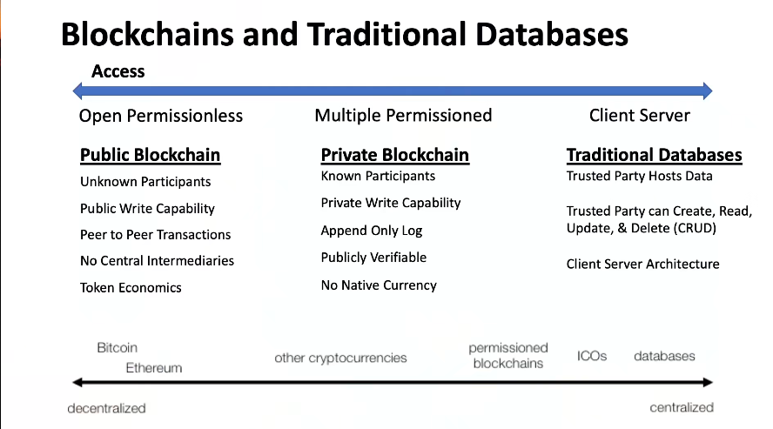

**Blockchain Economics**

· Can Lower Verification Costs:

· Direct Costs

· Privacy Costs

· Censorship Risks

· Settlement and Finality Risks

· Costs of Trust

· Economic Rents

·Network Incentive System:

· Reward , Affinity and Identity

· Starting or Operating